**How do I check the version of the SSL VPN client (FortiClient VPN)**

KI 0842

**How do I check the version of the SSL VPN client (FortiClient VPN) running on my device?**  
  
Launch the FortiClient VPN application & depending on the version you have installed click one of the options:

1. Click About on Home screen
2. Click Help > About
3. Click on the  icon on top right of window

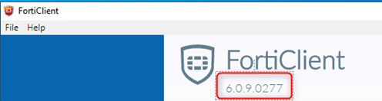

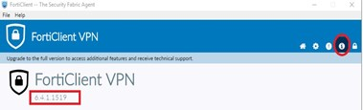

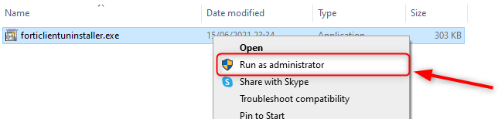Top of Form

Bottom of Form